**公衛三 梁嫚芳 b07801003**

**Homework: (4 points for fixed effects and random effects estimates, 4 points for their standard errors; 8 points totally)**

1. 針對講義「LinWY_Repeated_Introduction.doc」page 6 模式：，資料檔可由今日ceiba課程區下載：milk.csv，請以任何一個軟體計算  (fixed effect) 與  () (random effects) 係數估計值，及其相對應的standard errors。請附上程式碼或計算過程，並請與今日ceiba SAS program 『milk_estimate.sas』 之 output 作比較。

R output: (1st元素為μ ，其餘依序為bi)

係數估計值

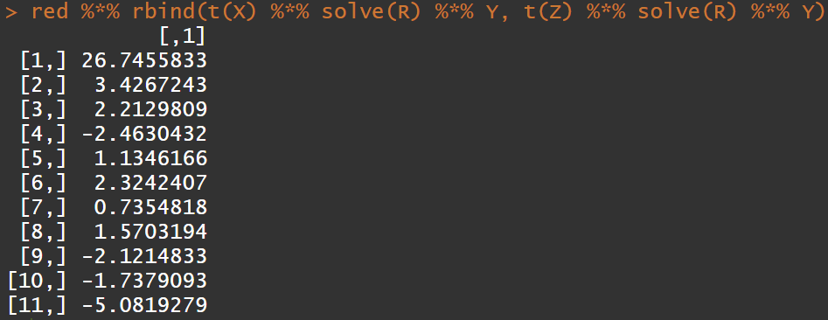

standard errors



SAS output:

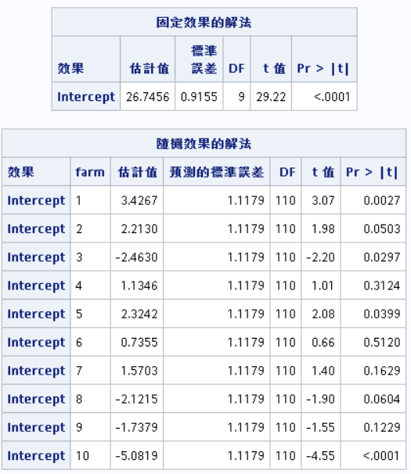

利用R計算的結果與SAS output相同。

R code:

data <- read.csv(file.choose())

X <- rep(1,120)

R <- diag(6.6729,120)

Z <- matrix(0,120,10)

for(i in 1:10){

Z[(12*i-11):(12*i),i] <- 1

}

G <- diag(7.8247,10)

Y <- matrix(data$milk, ncol=1)

red <- solve(rbind(cbind(t(X) %*% solve(R) %*% X, t(X) %*% solve(R) %*% Z),cbind(t(Z) %*% solve(R) %*% X, (t(Z) %*% solve(R) %*% Z + solve(G)))))

sqrt(diag(red))

red %*% rbind(t(X) %*% solve(R) %*% Y, t(Z) %*% solve(R) %*% Y)

SAS code:

**data** milk;

input farm milk;

cards;

1 32.33

1 29.47

1 30.19

1 28.37

1 29.10

1 28.19

1 30.28

1 29.28

1 30.37

1 31.37

1 34.38

1 31.66

2 30.99

2 31.55

2 31.06

2 32.01

2 28.28

2 22.27

2 25.24

2 26.77

2 29.42

2 31.04

2 29.89

2 30.87

3 26.33

3 26.32

3 26.74

3 22.49

3 23.16

3 19.95

3 19.70

3 19.09

3 24.57

3 28.74

3 28.36

3 23.84

4 35.73

4 31.78

4 25.60

4 23.29

4 28.14

4 25.92

4 26.07

4 25.69

4 27.25

4 29.69

4 28.29

4 28.08

5 29.69

5 31.92

5 29.51

5 30.64

5 30.75

5 30.96

5 29.95

5 29.10

5 27.51

5 27.12

5 26.74

5 26.93

6 30.05

6 24.80

6 26.84

6 26.22

6 23.79

6 26.89

6 26.84

6 30.29

6 29.17

6 27.64

6 27.51

6 30.36

7 26.35

7 26.41

7 27.51

7 26.45

7 26.07

7 26.78

7 29.18

7 30.45

7 30.68

7 30.78

7 30.58

7 29.89

8 24.72

8 23.56

8 24.43

8 22.62

8 21.73

8 21.90

8 25.07

8 23.49

8 26.65

8 27.08

8 25.23

8 27.20

9 23.88

9 22.31

9 23.19

9 22.53

9 22.98

9 27.12

9 27.09

9 25.93

9 25.90

9 25.99

9 26.07

9 25.62

10 27.78

10 26.57

10 23.64

10 21.03

10 18.77

10 16.33

10 15.42

10 18.33

10 20.02

10 21.92

10 21.70

10 24.12

;

**proc** **mixed** data = milk;

class farm;

model milk = / s;

random intercept / subject = farm G vcorr s;

**run**;